



**Prepared By: Group 36**

**Team Leader: Ranabahu .R.M.R.R**

**Prepared For:**

**Ms. Thisarani Wickramainghe**

**May 25, 2024**

**Website Proposal**

Table of Contents

What is GoDrive? 2

What is GoDrive? 2

Introduction to our website 2

Key Functionalities 3

Proposal Design 4

Time Frame 5

Contribution 5

# What is GoDrive?

"GoDrive: Unleash Your Journey" is a catchy and descriptive slogan that captures the essence of the car rental experience in Sri Lanka. It perfectly reflects the excitement and freedom of exploring the beautiful country!

# What is GoDrive?

"GoDrive: Unleash Your Journey" is a catchy and descriptive slogan that captures the essence of the car rental experience in Sri Lanka. It perfectly reflects the excitement and freedom of exploring the beautiful country!

# Introduction to our website

Our initiative, "GoDrive," is an innovative endeavour that aims to transform how people access and use cars. GoDrive aims to serve a variety of customer demands, both inside and beyond the university community, by emphasising rental choices.

The process of designing, creating, and launching GoDrive as a full platform for vehicle

rentals is summarised below. It examines the state of the market, points out major obstacles, outlines our strategy and displays the technological powerhouse that underpins the platform's design. It also explores the GoDrive user experience, operational dynamics, and future prospects that are envisaged.

With creative ideation and teamwork, GoDrive aims to reinvent the mobility experience by providing our consumers with affordability, dependability, and convenience. We aim negotiate the complexities of contemporary travel options and clear the path for a vibrant mobility future.

⁠Project Description

Through our platform we aim to provide an authentic and reliable vehicle rental experience for our customers. This platform allows our guests to rent vehicles with a hassle-free process which enables them to explore the beauty of our country with freedom.

We focus on providing an unparalleled travel experience for our guests by providing vehicles of best condition that will cater to their needs and ensure a comfortable journey. Our service also provide additional perks such as providing variety of coverage options for best protection, flexible subscription facilities etc..

We have made it possible for our guests to select their vehicle for rent out of a diverse selection ranging from high end to low luxury vehicles. Most importantly it allows our guests to rent vehicles from anywhere around the world by simply heading over to our online rental reservation system.

# Key Functionalities

* Vehicle Determination and Bookin**g:**

Customers can browse our vehicles, sifting by car sort, highlights, and capacity to discover them culminate fit. A user-friendly calendar permits for simple determination of rental dates and duration. Secure online booking framework encourages consistent reservation affirmation.

* **Client Account Management:**

Create a client account to spare individual subtle elements and oversee past bookings.

Access online articulations and track up and coming rentals.

* **Vehicle Administration (Framework Administrator):**

Add unused vehicles to the accounting subtle elements like demonstrate, highlights, and images. Update existing vehicle data to preserve accuracy. Deactivate inaccessible vehicles for booking purposes.

* **Stock Administration (Framework Administrator):**

Monitor real-time vehicle accessibility to guarantee effective booking management.

Set estimating for distinctive vehicle categories and rental durations.

Manage uncommon offers and advancements to pull in clients.

* **Secure Transactions:**

Our platform uses secure payment methods for safe and easy online transactions.

* **User Roles:**

Client: Centers on looking, selecting, and booking rental vehicles. Oversees their account data and rental history.

* **System Director:**

Supervises the platform's usefulness. Oversees vehicle subtle elements, stock, estimating, and client accounts.

* **CRUD Operations:**

GoDrive utilizes CRUD (Create, Read, Update, Delete) operations to guarantee proficient

information management:

* Create: Include modern vehicles to make client accounts, and set up rental bookings.
* Read: Clients can see vehicle points of interest and estimating. Framework directors can get booking data and client accounts.
* Update: Adjust vehicle data, upgrade estimating and advancements, and permit

client account edits.

* Delete: Framework chairmen can deactivate inaccessible vehicles or expel

obsolete information.

GoDrive enables a consistent car rental involvement in Sri Lanka. Let us assist you unleash your travel!

# A screenshot of a black and white website Description automatically generatedProposal Design

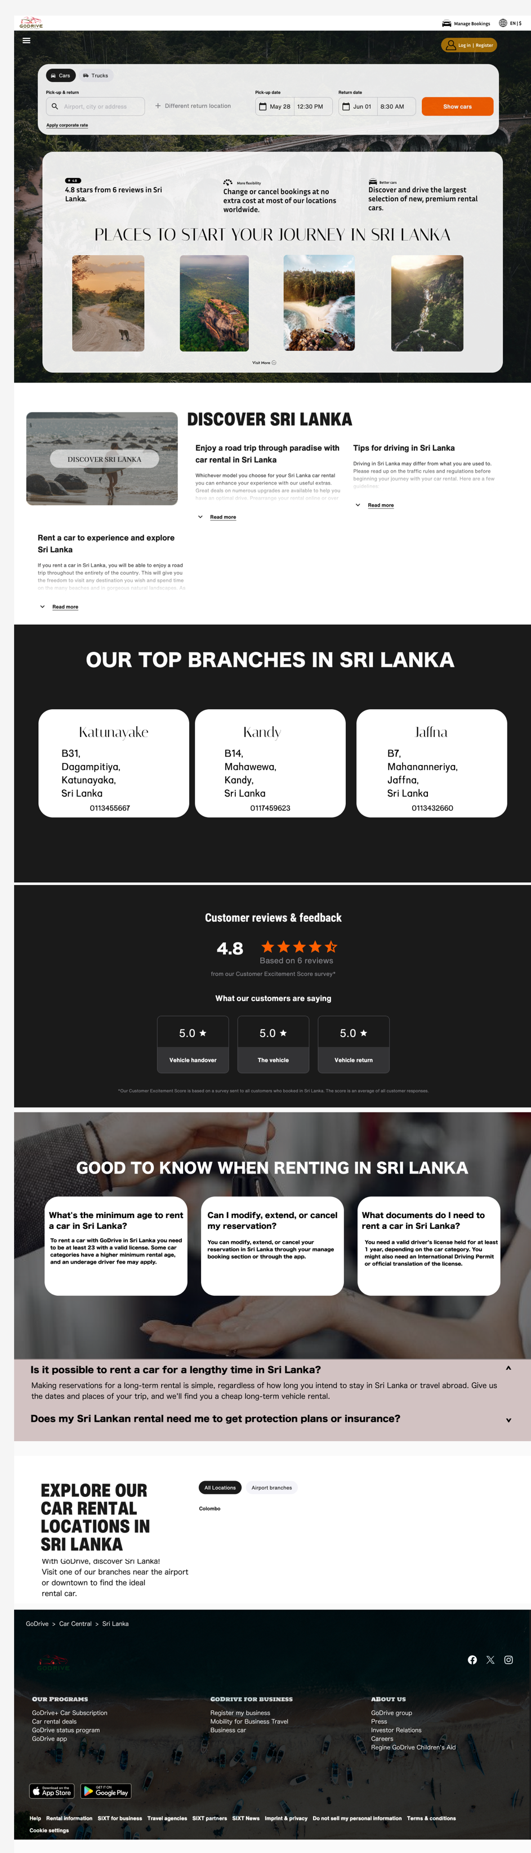

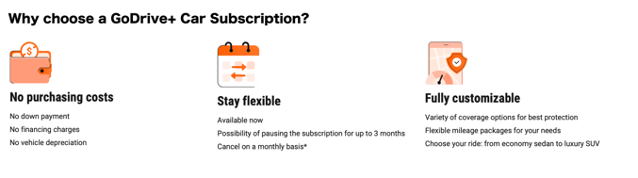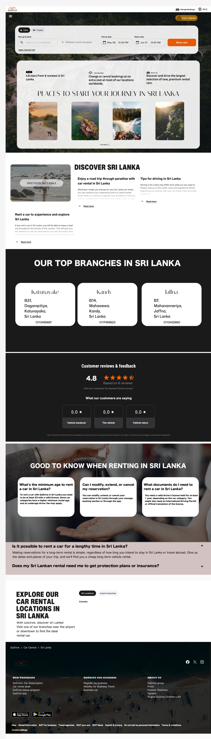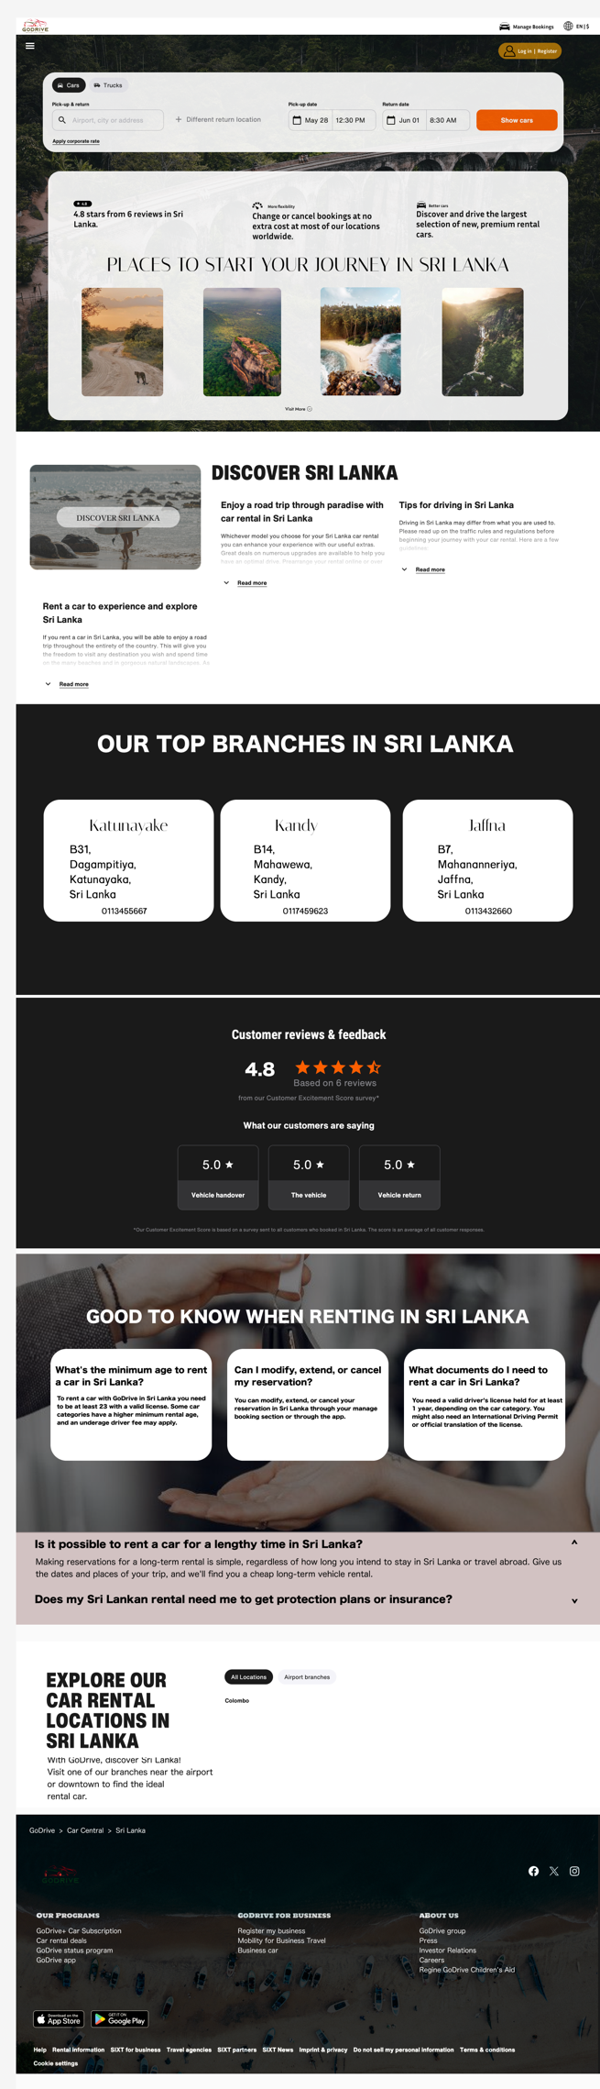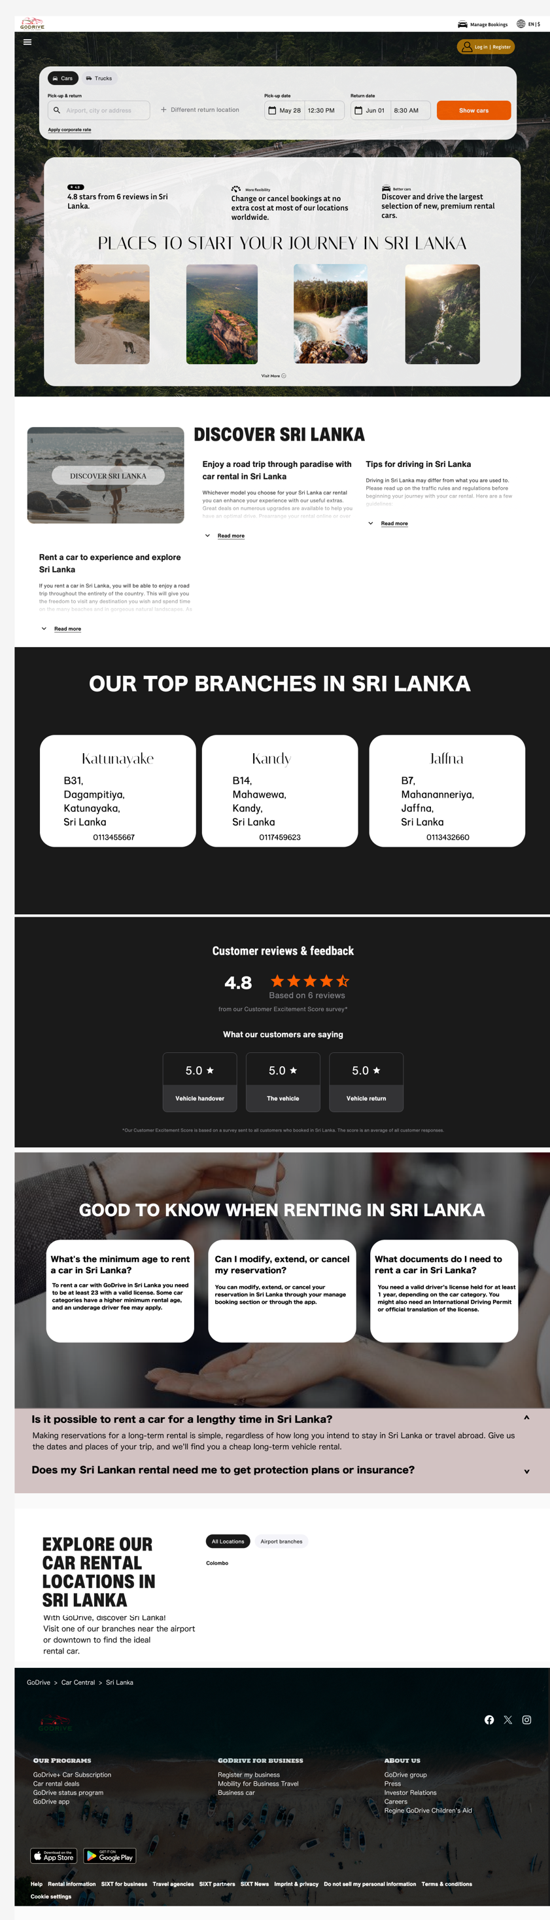

Figma Design Link: <https://www.figma.com/design/YdU7DwkTtMp6eexfQWJloO/Untitled?node-id=0-1&t=mIdezHfyx49Tuntx-0>

# Time Frame



|  |  |  |  |
| --- | --- | --- | --- |
| **Number** | **Student ID** | **Student Name** | **Contribution** |
| 01. | 26375 | Weeraman.D.M.M | Introduction |
| 02. | 29555 | Liyange.M.P |
| 03. | 30537 | Thenura.W.P.P | Project Discription |
| 04. | 30536 | Jayaweera.M.U.I |
| 05. | 26434 | Gunathilake.L.A.B.S | Functionalities |
| 06. | 26703 | Herath.H.M.D.D |
| 07. | 26758 | Ranabahu.R.M.R.R | Mockup Design |
| 08. | 26713 | Pathinayake.D.D.S |
| 09. | 29479 | Edirisinghe.A.R.T | Technology Stack |
| 10. | 29431 | Perera.P.A.S |

Contribut

# Contribution